**IT Lab 5: Developing Web Application using Django**

**Name:** GP Anirudh

**Roll Number:** 59

**Section:** B

**Batch:** B2

**Registration Number:** 180905452

1) Create a web form which allows the teacher to enter the student details like name, date of birth, address, contact number, email id and marks of English, Physics and Chemistry. After filling all the information and on clicking submit button, details should be added to a text area displayed on the same page. Display the total percentage of marks obtained in a label.

**templates/home.html**

<html lang="en">

<head>

<meta charset="UTF-8">

<meta http-equiv="X-UA-Compatible" content="IE=edge">

<meta name="viewport" content="width=device-width, initial-scale=1.0">

<title>Home</title>

</head>

<body>

<script type="text/javascript">

function process(){

document.getElementById('n').innerHTML = document.getElementById('name').value;

document.getElementById('cn').innerHTML = document.getElementById('cno').value;

document.getElementById('ema').innerHTML = document.getElementById('email').value;

document.getElementById('em1').innerHTML = document.getElementById('em').value;

document.getElementById('pm1').innerHTML = document.getElementById('pm').value;

document.getElementById('cm1').innerHTML = document.getElementById('cm').value;

var n1 = parseInt(document.getElementById('em').value);

var n2 = parseInt(document.getElementById('pm').value);

var n3 = parseInt(document.getElementById('cm').value);

var total = ((n1+n2+n3)/300)*100;

document.getElementById('tp').innerHTML = total

}

</script>

Name: <input type="text" name = "name" id = "name"><br>

Contact No: <input type="text" name= "cno" id = "cno"><br>

Email: <input type="text" name = 'email' id='email'><br>

English marks: <input type="text" name="em" id='em'><br>

Physics marks: <input type="text" name="pm" id='pm'><br>

Chemistry marks: <input type="text" name="cm" id = 'cm'><br>

<button onclick="process()">Submit</button>

<table>

<tr>

<td>Name: </td>

<td id="n">{{name}}</td>

</tr>

<tr>

<td>contact: </td>

<td id = "cn">{{cno}}</td>

</tr>

<tr>

<td>email: </td>

<td id = "ema">{{email}}</td>

</tr>

<tr>

<td>eng marks: </td>

<td id = "em1">{{em}}</td>

</tr>

<tr>

<td>phy marks: </td>

<td id="pm1">{{pm}}</td>

</tr>

<tr>

<td>chem marks: </td>

<td id="cm1">{{cm}}</td>

</tr>

<tr>

<td>Percentage: </td>

<td id='tp'>{{tp}}</td>

</tr>

</table>

</body>

</html>

**Form/views.py**

from django.shortcuts import render

from django.http import HttpResponse

# Create your views here.

def home(request):

return render(request,'home.html',{'name':'NA','cno':'NA','email':'NA','em':'NA','pm':'NA','cm':'NA','tp':'NA'})

**Form/urls.py**

from django.urls import path

from . import views

urlpatterns = [

path('',views.home,name="home"),

]

**q1/urls.py**

from django.urls import path,include

urlpatterns = [

path('admin/', admin.site.urls),

path('',include("form.urls"))

]

**q1/settings.py**

TEMPLATES = [

{

'BACKEND': 'django.template.backends.django.DjangoTemplates',

'DIRS': [os.path.join(BASE_DIR, 'form/templates')],

'APP_DIRS': True,

'OPTIONS': {

'context_processors': [

'django.template.context_processors.debug',

'django.template.context_processors.request',

'django.contrib.auth.context_processors.auth',

'django.contrib.messages.context_processors.messages',

],

},

},

]

**Output:**

­­­­ 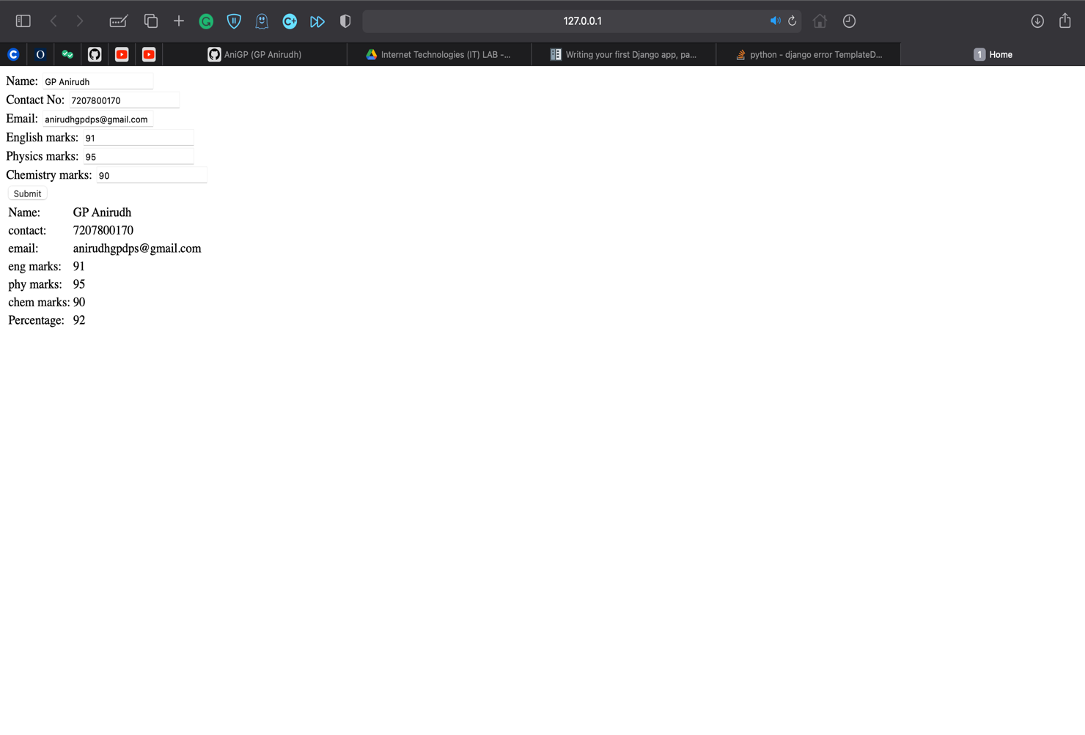

2) Create a web form with employee idsin dropdown list. Use a textbox for accepting date of joining. Add a button named “Am I Eligible for Promotion”. On clicking the button, if he has more than 5 years of experience, then display “YES” else “NO” in the label control.

**templates/home.html**

<html lang="en">

<head>

<meta charset="UTF-8">

<meta http-equiv="X-UA-Compatible" content="IE=edge">

<meta name="viewport" content="width=device-width, initial-scale=1.0">

<title>Document</title>

</head>

<body>

<form action="selection">

<label for="items">choose an id:</label>

<select id="items" name="emid">

<option value="item1">180905123</option>

<option value="item2">180905221</option>

<option value="item3">180905343</option>

<option value="item4">180905480</option>

<option value="item5">180905555</option>

</select><br>

enter the date of joining: <input type="date" id = "doj" name="doj"><br>

<input type="submit" value="submit"><br>

</form>

</body>

</html>

**Templates/result.html**

<html lang="en">

<head>

<meta charset="UTF-8">

<meta http-equiv="X-UA-Compatible" content="IE=edge">

<meta name="viewport" content="width=device-width, initial-scale=1.0">

<title>Result</title>

</head>

<body>

{{selection}}

</body>

</html>

**q2/views.py**

from django.shortcuts import render

from django.http import HttpResponse

# Create your views here.

def home(request):

return render(request,'home.html')

def select(request):

n1 = request.GET['doj']

n2 = int(n1[:4])

if 2021-n2>5:

n1 = "CONGRATULATIONS YOU ARE ELGIBLE FOR PROMOTION"

else:

n1 = "SORRY YOU ARE NOT ELGIBLE FOR THE PROMOTION"

return render(request,'result.html',{"selection":n1})

**form/urls.py**

from django.urls import path

from . import views

urlpatterns = [

path('',views.home,name="home"),

path('selection',views.select,name='selection')

]

**q2/settings.py**

TEMPLATES = [

{

'BACKEND': 'django.template.backends.django.DjangoTemplates',

'DIRS': [os.path.join(BASE_DIR,'empform/templates')],

'APP_DIRS': True,

'OPTIONS': {

'context_processors': [

'django.template.context_processors.debug',

'django.template.context_processors.request',

'django.contrib.auth.context_processors.auth',

'django.contrib.messages.context_processors.messages',

],

},

},

**Output:**

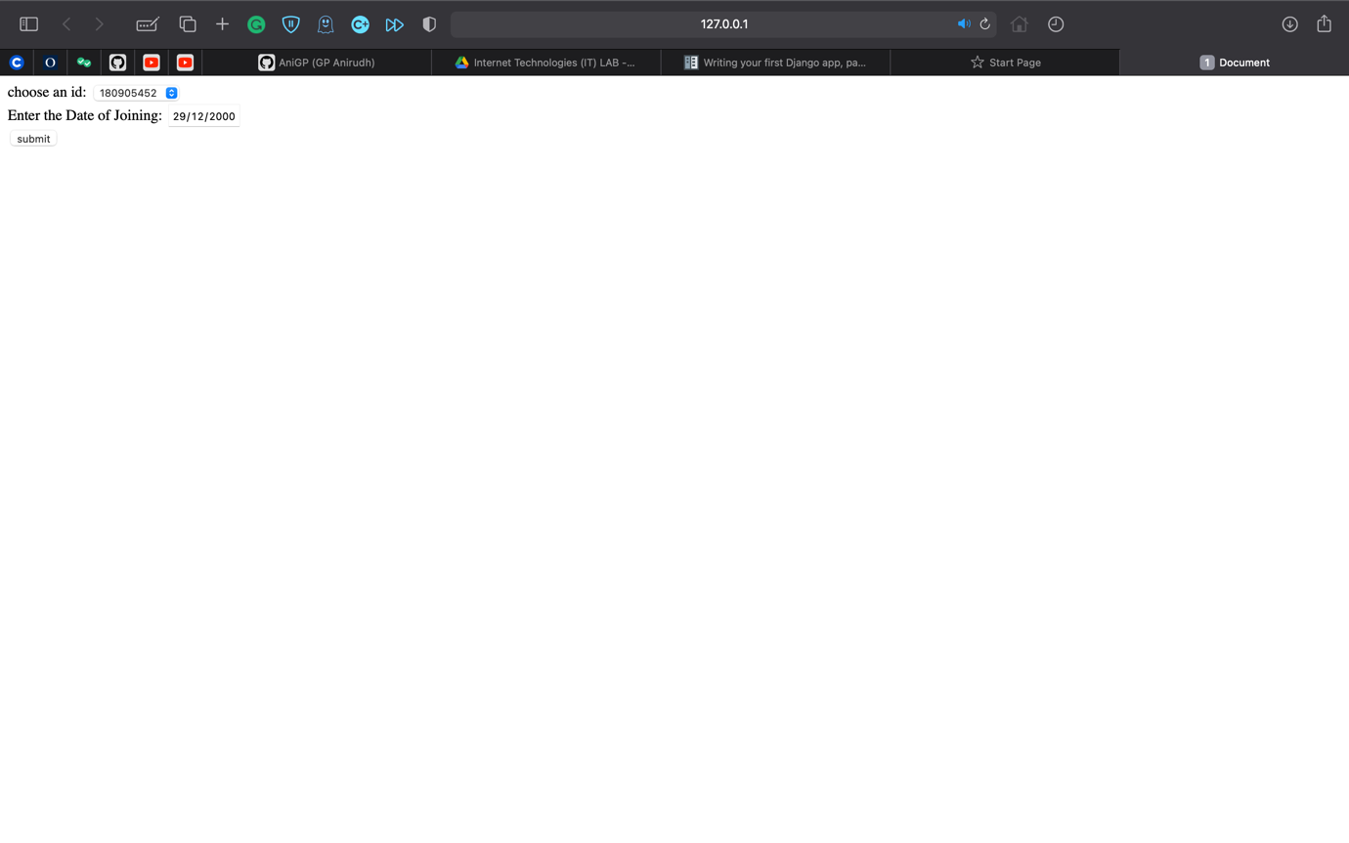

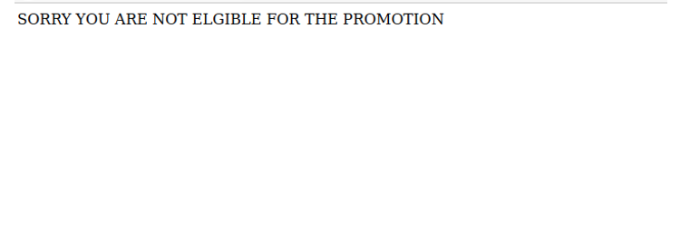

3) Develop a simple web page to perform basic arithmetic operations. Take two integer inputs from the user, select the operation to be performed using a

dropdown. Include a button “Calculate” to perform the selected operation, and then display the result in the same web page.

**templates/home.html**

<html lang="en">

<head>

<meta charset="UTF-8">

<meta http-equiv="X-UA-Compatible" content="IE=edge">

<meta name="viewport" content="width=device-width, initial-scale=1.0">

<title>Document</title>

</head>

<body>

<script type="text/javascript">

function calculator(){

var n1 = parseFloat(document.getElementById('num1').value);

var n2 = parseFloat(document.getElementById('num2').value);

var n3 = document.getElementById('op').value;

if(n3=="+"){

n4 = n1+n2;

}

else if(n3=="-"){

n4 = n1-n2;

}

else if(n3=="*"){

n4 = n1*n2;

}

else if(n3=="/"){

n4=n1/n2;

}

document.getElementById('result').innerHTML = n4;

}

</script>

<input type="number" id = 'num1'><br>

<input type="number" id = 'num2'><br>

<label for="op">select the operation to be performed</label>

<select name="op" id="op">

<option value="+">+</option>

<option value="-">-</option>

<option value="*">*</option>

<option value="/">/</option>

</select>

<br>

<button onclick="calculator()">calculate</button><br>

<h3 id="result"></h3>

</body>

</html>

**form/views.py**

from django.shortcuts import render

from django.http import HttpResponse

# Create your views here.

def home(request):

return render(request,'home.html')

**form/urls.py**

from django.urls import path

from . import views

urlpatterns = [

path('',views.home,name="home"),

]

**q2/urls.py**

from django.contrib import admin

from django.urls import path

from django.conf.urls import include

urlpatterns = [

path('admin/', admin.site.urls),

path('',include("form.urls"))

]

**q2/settings.py**

TEMPLATES = [

{

'BACKEND': 'django.template.backends.django.DjangoTemplates',

'DIRS': [os.path.join(BASE_DIR,'empform/templates')],

'APP_DIRS': True,

'OPTIONS': {

'context_processors': [

'django.template.context_processors.debug',

'django.template.context_processors.request',

'django.contrib.auth.context_processors.auth',

'django.contrib.messages.context_processors.messages',

],

},

},

**Output:**

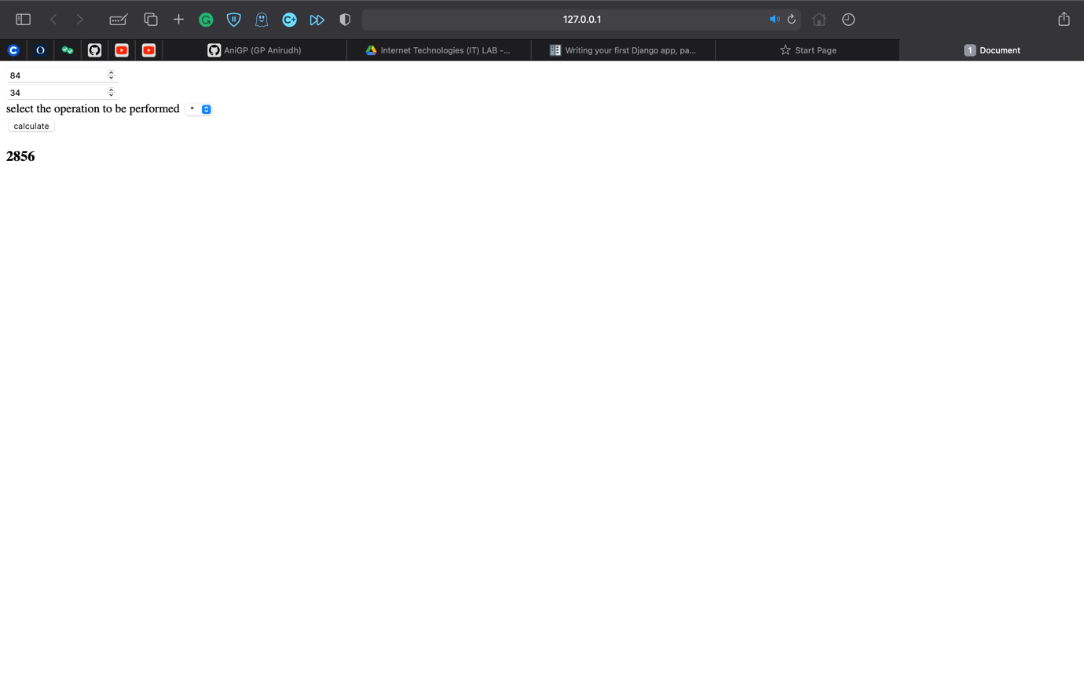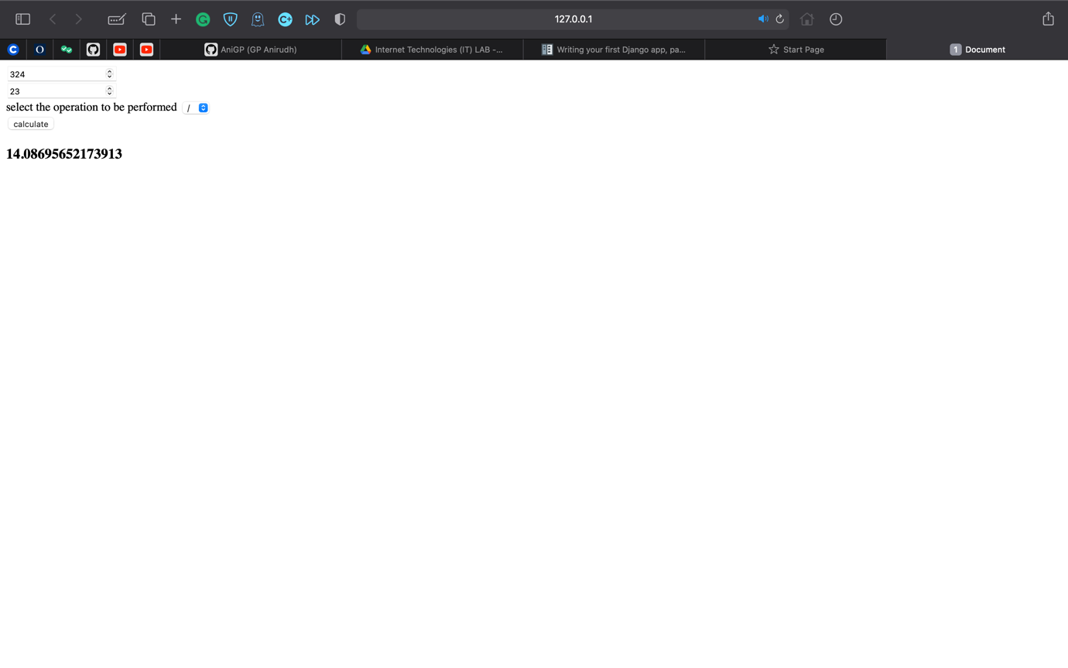

4) Develop a simple web form that generates the front cover for a magazine. The form should provide the options for selecting the image, background color,

changing font size, color etc. Input messages must be taken from the user so as to display it on the front cover with legible font family and font size. The front cover developed should be proportionate to the web page size. Place the css files inside static folder.

**templates/home.html**

{%load static %}

<html lang="en">

<head>

<link rel="stylesheet" href="{% static 'css/q4.css' %}">

<meta charset="UTF-8">

<meta http-equiv="X-UA-Compatible" content="IE=edge">

<meta name="viewport" content="width=device-width, initial-scale=1.0">

<title>Document</title>

</head>

<body>

<script>

function colorChange(color){

document.getElementById('mag').style.backgroundColor=color;

}

function enterText(){

document.getElementById('ct').innerHTML = document.getElementById('text').value;

document.getElementById('ct').style.fontSize=document.getElementById('fs').value;

document.getElementById('ct').style.fontFamily = document.getElementById('font').value;

}

function bgChange1(){

document.getElementById('mag2').style.backgroundImage='url("https://www.extremetech.com/wp-content/uploads/2016/10/Lamborghini-Egoista-LF-3-4-HERO-640x354.jpg")';

document.getElementById('mag2').style.backgroundSize = 'cover';

document.getElementById('mag2').style.backgroundRepeat='no-repeat';

}

function bgChange2(){

document.getElementById('mag2').style.backgroundImage='url("https://superstarsbio.com/wp-content/uploads/2019/04/Robert-Downey-Jr.-Smile.jpg")';

document.getElementById('mag2').style.backgroundSize = 'cover';

document.getElementById('mag2').style.backgroundRepeat='no-repeat';

}

</script>

<table style="height: 100%;">

<tr>

<td id="col1">

<table style="border-spacing: 0px 50px;">

<tr><th>select color:</th><th><button id="c1" onclick="colorChange('coral')" class="c"></button></th><th><button id="c2" onclick="colorChange('cornflowerblue')" class="c"></button></th><th><button id = "c3" onclick="colorChange('yellow')" class="c"></button></th><th><button id="c4" onclick="colorChange('lightgreen')" class="c"></button></th></tr>

<tr>

<th>select image:</th>

<th><button id="i1" onclick="bgChange1()" class="i"></button></th>

<th><button id="i2" onclick="bgChange2()" class="i"></button></th>

</tr>

</table>

<table>

<tr>

<th>enter the Text: </th>

<th><textarea name="text" id="text" cols="30" rows="10"></textarea></th>

</tr>

</table>

<table>

<tr>

<th>select the font: </th>

<th><select name="fonts" id="font">

<option value="Times New Roman">Times New Roman</option>

<option value="Arial">Arial</option>

<option value="Helvetica">Helvetica</option>

<option value="sans-serif">sans-serif</option>

<option value="Lucida Console">Lucida Console</option>

</select></th>

</tr>

</table>

<table>

<tr>

<th>enter the font-size:</th>

<th><input type="number" id="fs"></th>

</tr>

</table>

<button onclick="enterText()">submit</button>

</td>

<td id="mag">

<div id="mag2">

<h1 id="magHead">MIT</h1>

</div>

<p id="ct"></p>

</td>

</tr>

</table>

</body>

</html>

**q4/settings.py**

STATICFILES_DIRS = [

os.path.join(BASE_DIR,'static')

]

STATIC_ROOT = os.path.join(BASE_DIR, 'assets')

**form/views.py**

from django.shortcuts import render

from django.http import HttpResponse

# Create your views here.

def home(request):

return render(request,'home.html')

**q4/urls.py**

from django.contrib import admin

from django.urls import path

from django.conf.urls import include

urlpatterns = [

path('admin/', admin.site.urls),

path('',include("form.urls"))

]

**form/urls.py**

from django.urls import path

from . import views

urlpatterns = [

path('',views.home,name="home"),

]

**Static/css/q4.css**

#col1{

width: 40%;

}

#col2{

width:40%;

}

.c{

height: 50px;

width: 50px;

margin: 0px 20px;

}

#c1{

background-color: coral;

}

#c2{

background-color: cornflowerblue;

}

#c3{

background-color:yellow;

}

#c4{

background-color: lightgreen;

}

#i1{

background-image: url("https://www.extremetech.com/wp-content/uploads/2016/10/Lamborghini-Egoista-LF-3-4-HERO-640x354.jpg");

background-size: 100px;

background-repeat: no-repeat;

background-position: center;

height: 60px;

width: 80px;

}

#i2{

background-image: url("https://superstarsbio.com/wp-content/uploads/2019/04/Robert-Downey-Jr.-Smile.jpg");

background-size: 100px;

background-repeat: no-repeat;

background-position: center;

height: 60px;

width: 80px;

}

.i{

margin: 0px 20px;

}

#mag{

text-align: center;

height: 1000%;

}

#magHead{

font-family: cursive;

font-size: 800%;

color: white;

}

#mag2{

height: 50%;

text-align: center;

}

**Output:**

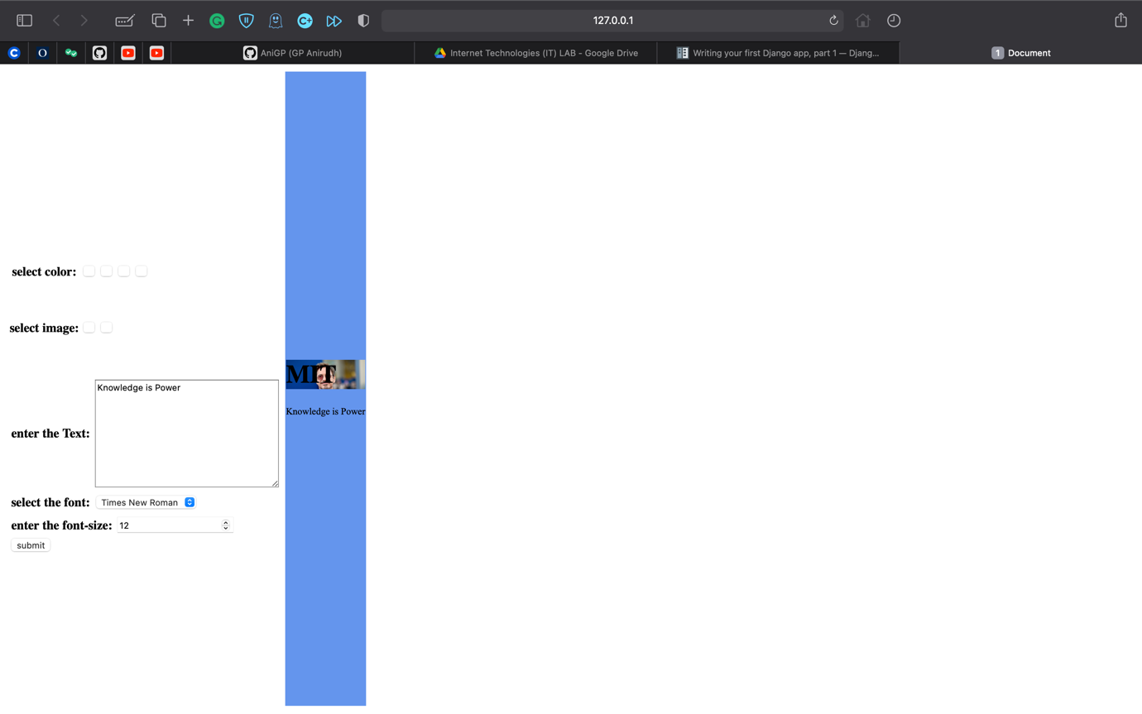

**Additional Excercises:**

1. Develop a simple web page to reproduce the given Captcha. Upon match, suitable message has to be displayed. If there is a mismatch for more than 3 times, TextBox has to be disabled.

**Templates/home.html**

{%load static %}

<html lang="en">

<head>

<meta charset="UTF-8">

<meta http-equiv="X-UA-Compatible" content="IE=edge">

<meta name="viewport" content="width=device-width, initial-scale=1.0">

<title>Document</title>

</head>

<body>

<script>

var count = 0;

function validate(){

var c = document.getElementById('inp').value;

if(c=='hfnhv'){

document.getElementById('smg').innerHTML = "This is the message to be displayed";

}

else if(count<3){

count+=1; }

else{

document.getElementById('inp').disabled = true;

document.getElementById('smg').innerHTML = 'You exceeded the maximum number of attempts';

}

}

</script>

<img src="{% static 'images/q5.png' %}" alt="captcha" style="height:

150px;"><br>

<textarea name="inp" id="inp" cols="20" rows="1" style="font-size:

18px;"></textarea><br>

<button onclick="validate()">submit</button><br>

<p id="smg"></p>

</body>

</html>

**form/views.py**

from django.shortcuts import render

from django.http import HttpResponse

import random

# Create your views here.

def home(request):

return render(request,'home.html')

**form/urls.py**

from django.urls import path

from . import views

urlpatterns = [

path('',views.home,name="home"),

]

**Output:**









2) Design a simple web application to provide information about a book. The home page of the application should display the cover page of the book along with three hyperlinks: Metadata, Reviews, Publisher info. Give provision to revert to home page from any other page.

**Templates/home.html:**

<html lang="en">

<head>

<meta charset="UTF-8">

<meta http-equiv="X-UA-Compatible" content="IE=edge">

<meta name="viewport" content="width=device-width, initial-scale=1.0">

<title>Document</title>

</head>

<body style="background-image:

url('https://tbivision.com/files/2020/05/Percy-Jackson.jpg');background-size:

1000px;">

<table style="font-size: 20px;margin: 0px 10px;">

<tr>

<th><a href="{% url 'metaData' %}">metadata</a></th>

<th><a href="{% url 'review' %}">review</a></th>

<th><a href="{% url 'author' %}">author info</a></th>

</tr>

</table>

<br>

<h1 style="color: white;">Overview</h1><br>

<p style="color: white;">

Percy Jackson & the Olympians, often shortened to Percy Jackson or PJO, is a pentalogy of fantasy adventure novels written by American author Rick Riordan, and the first book series in the Camp Half-Blood Chronicles.

Five supplementary books, along with graphic novel versions of each book in the first series have also been released. More than 69 million copies of the books have been sold in more than 35 countries.

<br>

As of October 28, 2011, the books have been on The New York Times Best Seller list for children's book series for 245 weeks. The first book was adapted into a film titled Percy Jackson & the Olympians:

The Lightning Thief in 2010, which was commercially successful, but due to major deviations from the books received mixed reviews from fans around the world. An adaptation of the second book,

titled Percy Jackson: Sea of Monsters, was released in 2013.

<br>

A TV series adaptation is in development for Disney+, but as of April 2021, no release date has been announced.

</p>

</body>

</html>

**templates/review.html**

<html lang="en">

<head>

<meta charset="UTF-8">

<meta http-equiv="X-UA-Compatible" content="IE=edge">

<meta name="viewport" content="width=device-width, initial-scale=1.0">

<title>review</title>

</head>

<body style="background-image:

url('https://tbivision.com/files/2020/05/Percy-Jackson.jpg');background-size:

1000px;">

<a href="{% url 'home' %}" style="font-size: 20px;">home</a><br>

<h1 style="color: white;">Review</h1>

<pre style="color: white;font-size: 15px;">

TThe Lightning Thief received mostly positive reviews and won awards including the School Library Journal Best Book of 2005.

The New York Times praised The Lightning Thief as “perfectly paced, with electrifying moments chasing each other like heartbeats”.

Author Rick Riordan said of the various awards:

"The ultimate compliment for a children's writer is when the kids like it."

Like its predecessor, The Sea of Monsters won several prizes and received generally positive reviews as well.

It sold over 100,000 copies in hardcover by the time it was released in paperback and reviewers have praised the storyline,

themes and the author's style of writing. Matt Berman, of Common Sense Media, praised the book,

saying “The Percy Jackson series continues to be pure fun, with the author doing nearly everything right t

o produce a book that few kids will be able to resist.”[30] Kirkus reviewed The Battle of the Labyrinth as,

“This volume can stand alone, but no one will be able to read just one

look no further for the next Harry Potter, meet Percy Jackson as legions of fans already have.”

As of December 11, 2019, it has been on the New York Times Children's Series Best Seller List for 665 weeks.

</pre>

</body>

</html>

**templates/metadata.html:**

<html lang="en">

<head>

<meta charset="UTF-8">

<meta http-equiv="X-UA-Compatible" content="IE=edge">

<meta name="viewport" content="width=device-width, initial-scale=1.0">

<title>meta data</title>

</head>

<body style="background-image:

url('https://tbivision.com/files/2020/05/Percy-Jackson.jpg');background-size:

1000px;">

<a href="{% url 'home' %}" style="font-size: 20px;">home</a><br>

<h1 style="color: white;">meta data</h1>

<p style="color: white;">

<br>

Publisher Disney Hyperion (US)

Miramax Books (US, first edition)

Penguin Books/Puffin (UK, AU, NZ)<br>

Published 2005–2009

</p>

</body>

</html>

**templates/author.html:**

<html lang="en">

<head>

<meta charset="UTF-8">

<meta http-equiv="X-UA-Compatible" content="IE=edge">

<meta name="viewport" content="width=device-width, initial-scale=1.0">

<title>author</title>

</head>

<body style="background-image:

url('https://www.mkgandhi.org/images/autobio-deluxe.jpg');background-size:

1000px;">

<a href="{% url 'home' %}" style="font-size: 20px;">home</a><br>

<h1>About author</h1><br>

<pre style="font-size: 15px;">

Richard Russell Riordan Jr. is an American author.

He is known for writing the Percy Jackson & the Olympians series, about a teenager named Percy Jackson who discovers

he is a son of the Greek god Poseidon. Riordan's books have been translated into forty-two languages and sold more

than thirty million copies in the US.[2] 20th Century Fox adapted the first two books of his Percy Jackson series as

part of a series of films. His books have spawned related media, such as graphic novels and short story collections.

</pre>

</body>

</html>

**form/views.py**

from django.shortcuts import render

from django.http import HttpResponse

import random

#

# Create your views here.

def home(request):

return render(request,'home.html')

def meta(request):

return render(request,'metadata.html')

def review(request):

return render(request,'review.html')

def author(request):

return render(request,'author.html')

**q6/views.py**

from django.contrib import admin

from django.urls import path

from django.conf.urls import include

urlpatterns = [

path('admin/', admin.site.urls),

path('',include("form.urls"))

]

**Output:**

